**urriculum page 1** 

**itae**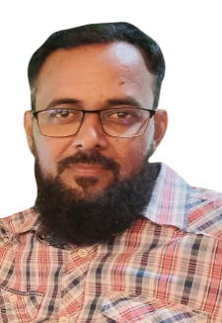

*ALISHA BUKHSH*

**Address:** House No. L-818, 5C-4, North Karachi

**Contact:** 0304-3879417

**E-mail:** [AlishaHassan1826@gmail.com](mailto:AlishaHassan1826@gmail.com)

**Objectives:** To struggle and strive the best in the favor and interests of this dynamic organization in order ``````````to flesh my future and to have a platform where I can utilize and practice my abilities and skills in the environments of challenging and cut throat competition in the paramount concern of this winning firm.

**Personal Profile:**

Father’s Name : Muhammad Bukhsh

Date of Birth : 26-06-2009

Religion : Islam

Marital Status : Single

Domicile : Karachi.

Nationality : Pakistani

:

**Academic Profile**

* + - **Matriculation** : (Medical) Bedal Bakers rohri

* + - **Intermediate** : pre Medical sir syed college .

**Language Flair**

* Fine Reading, Writing & Speaking Skills in English & Urdu.